US Credit Card Complaints Analysis Project

Table of Contents
- Project Overview
- Data Overview
- Objectives
- SQL and Tableau Calculated Fields
  - SQL Queries
  - Tableau Calculated Fields
- Tableau Visualization
- Insights and Recommendations
- Conclusion
- Additional Resources

Project Overview
This project focuses on analyzing credit card complaints data, offering insights into common issues, response times, and geographic distribution. By leveraging Tableau, the analysis provides a visual representation of complaint trends, helping stakeholders address customer pain points more effectively.

Data Overview
- Credit Card Complaints Data: This dataset includes complaints logged against various financial institutions, categorized by issues like billing disputes, identity theft, and others. It also includes details on company responses and the channels through which complaints were submitted.

Objectives
- Complaint Analysis: Identify the most common types of complaints and track their frequency over time.
- Response Analysis: Evaluate the efficiency of the companies in responding to complaints.
- Geographical Insights: Analyze the distribution of complaints across different regions.
- Customer Satisfaction: Examine the correlation between the type of response and customer satisfaction.

SQL and Tableau Calculated Fields

SQL Queries
Here are some example SQL queries used in this project:
CREATE DATABASE IF NOT EXISTS complaints_db
CHARACTER SET = 'utf8mb4'
COLLATE = 'utf8mb4_unicode_ci';

USE complaints_db;

CREATE TABLE IF NOT EXISTS complaints (
complaint_id VARCHAR(255) NOT NULL PRIMARY KEY,
complaint_id_alt VARCHAR(255),
company VARCHAR(255) NOT NULL,
company_public_response TEXT,
company_response_to_consumer TEXT,
complaint_category VARCHAR(200),
consumer_complaint_narrative TEXT,
consumer_consent_provided TINYINT(1) DEFAULT NULL, -- 1 = true, 0 = false, NULL = unknown
consumer_consent_group VARCHAR(100),
consumer_disputed TINYINT(1) DEFAULT NULL, -- 1 = true, 0 = false
date_received DATE,
date_sent_to_company2 DATE,
dimension VARCHAR(200),
issue VARCHAR(200),
product VARCHAR(200),
select_company_or_state VARCHAR(100),
state VARCHAR(100),
sub_issue VARCHAR(200),
sub_product VARCHAR(200),
submitted_via VARCHAR(100),
source_table_name VARCHAR(255),
tags JSON, -- JSON array of tags, e.g. '["tag1","tag2"]'
timely_response TINYINT(1) DEFAULT NULL,
zip_code VARCHAR(20),
avg_no_of_days DECIMAL(10,2),
donut JSON, -- store chart data/metadata here (or change to DECIMAL if numeric)
number_of_records INT,
created_at DATETIME DEFAULT CURRENT_TIMESTAMP,
updated_at DATETIME DEFAULT CURRENT_TIMESTAMP ON UPDATE CURRENT_TIMESTAMP
) ENGINE=InnoDB
DEFAULT CHARSET=utf8mb4
COLLATE=utf8mb4_unicode_ci;

-- Indexes for faster lookups
CREATE INDEX idx_company ON complaints(company);
CREATE INDEX idx_product ON complaints(product);
CREATE INDEX idx_date_received ON complaints(date_received);
CREATE INDEX idx_state ON complaints(state);

-- Load Data
BULK INSERT ComplaintsData
FROM 'path_to_your/credit_card_data.csv'
WITH (FIELDTERMINATOR = ',', ROWTERMINATOR = '\n', FIRSTROW = 2);

Data Cleaning
- Handle Duplicates & IDs
- Standardize Text Fields
- Handle Missing / Null Values
- Validate Dates & Timelines
- Numeric Fields

Data Type Conversions
- Convert Yes/No columns → Boolean (1/0).
- ZIP codes → keep as VARCHAR (leading zeros important).
- Dates → convert all to DATE type.
- Outlier & Consistency Checks

Dashboard charts and KPIs

Visual Card | Description | Calculation
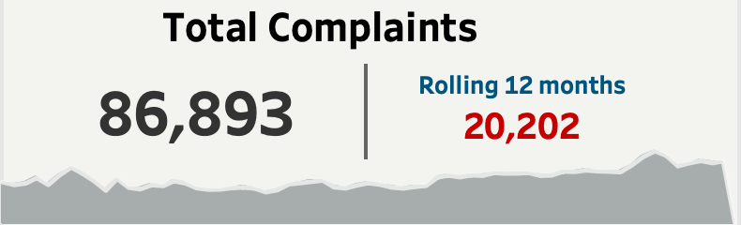 | KPI: Total Complaints and Last 12-month: This KPI presents the total number of credit card complaints received, along with the rolling value for the last twelve months, highlighting recent trends in complaint volume. | - SUM([Rolling 12 month complaints])  { FIXED : sum(IF [Rolling 12 month]= TRUE then ([Number of Records]) END)}  - (DATEDIFF('month', DATETRUNC('month',[Date received]),  DATETRUNC('month',[Maximun Date Parameter])))<12
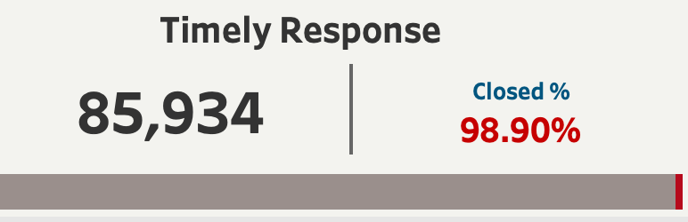 | KPI: In Progress & % of In-progress Complaints: This KPI tracks the number of complaints that are currently in progress, indicating the workload of customer service teams, along with the percentage of total complaints that are still unresolved. | - SUM([Timely Response])/SUM([Number of Records])  - IF [Timely response?]='Yes' then 1 else 0 END
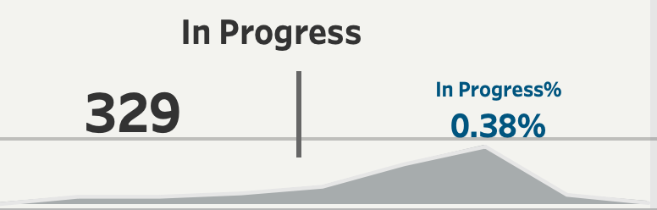 | KPI: Timely Response & % of Closed Complaints: This metric measures the proportion of closed complaints that received a timely response within a predefined timeframe, providing insights into customer service efficiency. | SUM(IF [Company response to consumer1]='In Progress' THEN [Number of Records] end)/SUM([Number of Records])
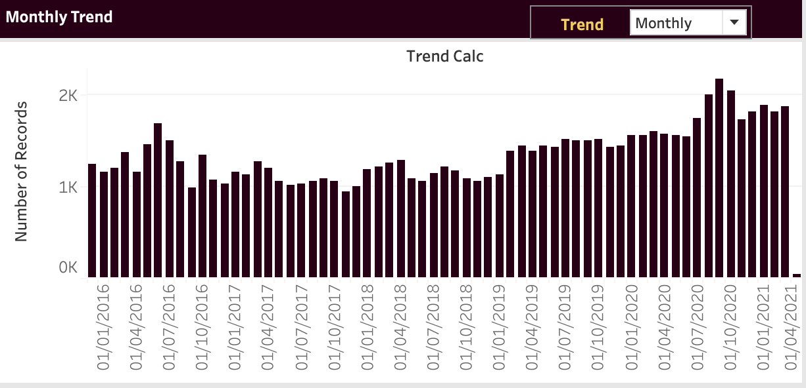 | Chart: Weekly Trend of Complaints: This visualization displays the weekly trend of credit card complaints over time, including an average line to identify patterns, and highlights the maximum value of complaints reported in a single week. | DATE((DATETRUNC([Trend],[Date received])))
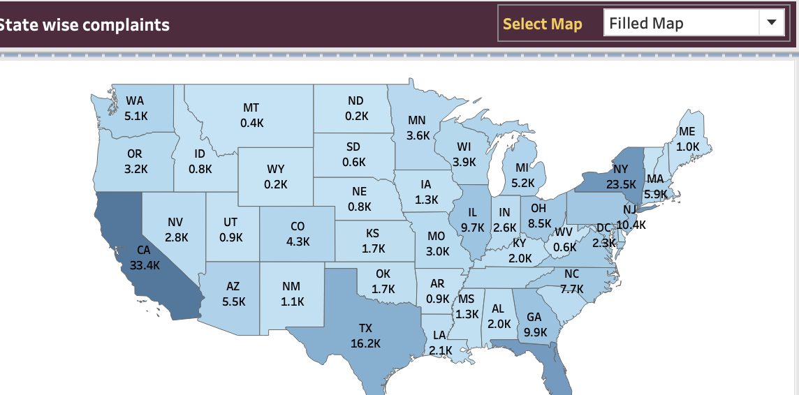 | Chart: State-wise Complaints Density Map: This chart showcases the geographical distribution of credit card complaints across different states, enabling stakeholders to identify regions with high complaint densities. | SUM([Number of Records])
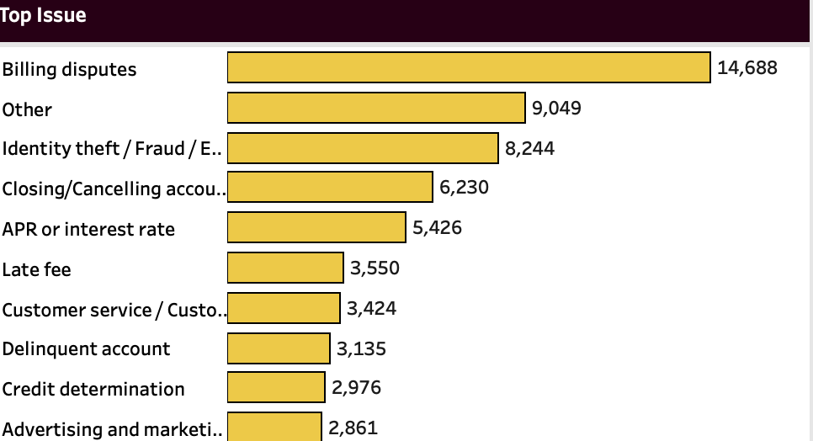 | Chart: Top Issue-wise Complaints: This visualization presents the top issues reported by customers, offering insights into the most common grievances faced by credit card users | SUM([Number of Records])
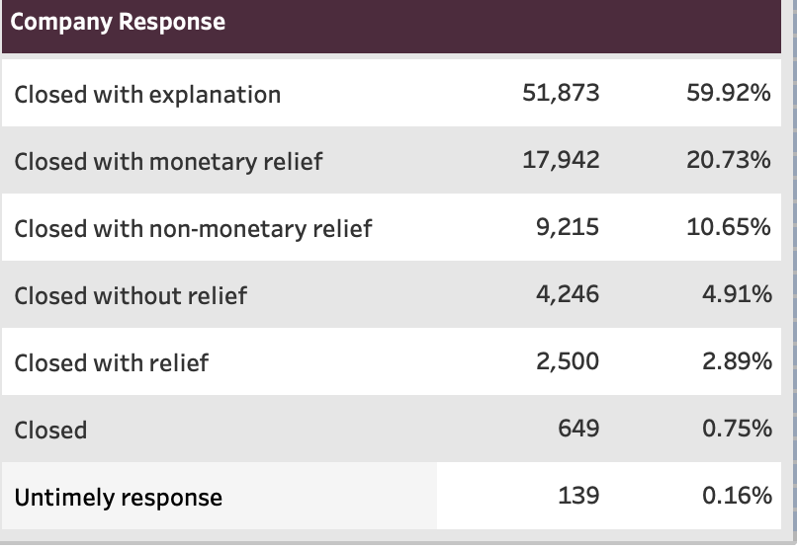 | Company Response by Total Complaints and % of Total: This chart illustrates the response rate of credit card companies to complaints, both in terms of the total number of complaints and the percentage of total complaints responded to. | SUM([Number of Records])
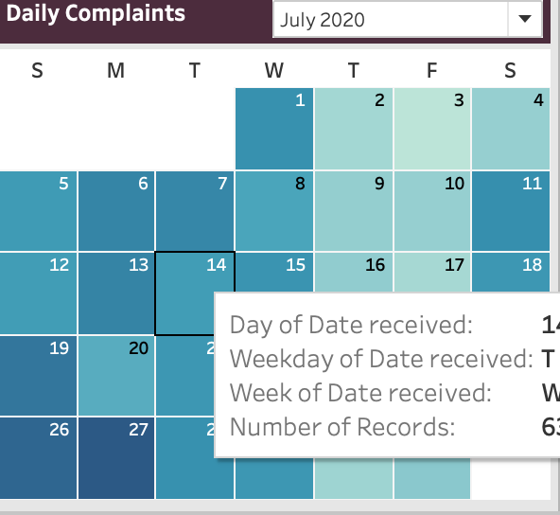 | Daily Complaints Heat Map in the Form of Calendar Chart: This visualization represents the daily distribution of credit card complaints using a calendar chart, allowing stakeholders to identify days with high complaint volumes | SUM([Number of Records])
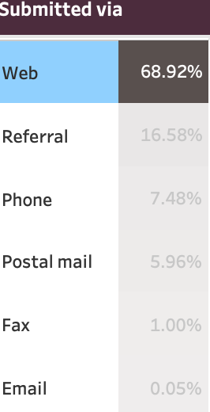 | Submitted via Total Complaints Chart: This chart categorizes complaints based on the channels through which they were submitted (e.g., phone, email, website), providing insights into customer communication preferences and channel effectiveness. | SUM([Number of Records])

Insights and Recommendations
Based on the analysis:
- Identify theft/ Fraud/Embezzelment: These are the most common complaints, indicating a need for improved billing processes.
- Geographical Focus: States like California and Texas have higher complaint rates, suggesting targeted customer service improvements in these areas.
- Response Efficiency: While most complaints are closed with an explanation, a higher focus on providing monetary relief might improve customer satisfaction.
- Submission Channels: A majority of complaints are submitted online, highlighting the importance of a user-friendly web interface for complaint submission.

Conclusion
This analysis provides critical insights into credit card complaint patterns, helping companies identify key areas for improvement in customer service and complaint resolution.

